**Aryaman Mishra**

**19BCE1027**

**Aim**

Consider a text file as input to the program. Write an efficient **OpenMP** program to identify the number of repetitions of words in the file and display it in the terminal. Let the program print the words and its repetitions along with the corresponding threadID. Let the processes pass the number of words it verified to one of the process which prints the same. Use a minimum of 2 processes for the purpose and implement the above process for any four words of your choice.

**Code**

#include <stdio.h>

#include <string.h>

#include <omp.h>

void main()

{

int count = 0,c = 0, i, j = 0, k, space = 0;

char str[100], p[50][100], str1[20], ptr1[50][100];

char *ptr;

printf("Enter the text file\n");

scanf(" %[^\n]s", str);

int nthreads,tid;

omp_set_num_threads(2);

#pragma omp parallel private(tid)

{

tid=omp_get_thread_num();

for (i = 0;i<strlen(str);i++)

{

if ((str[i] == ' ')||(str[i] == ',' && str[i+1] == ' ')||(str[i] == '.'))

{

space++;

}

}

for (i = 0, j = 0, k = 0;j < strlen(str);j++)

{

if ((str[j] == ' ')||(str[j] == 44)||(str[j] == 46))

{

p[i][k] = '\0';

i++;

k = 0;

}

else

p[i][k++] = str[j];

}

k = 0;

for (i = 0;i <= space;i++)

{

for (j = 0;j <= space;j++)

{

if (i == j)

{

strcpy(ptr1[k], p[i]);

k++;

count++;

break;

}

else

{

if (strcmp(ptr1[j], p[i]) != 0)

continue;

else

break;

}

}

}

for (i = 0;i < count;i++)

{

for (j = 0;j <= space;j++)

{

if (strcmp(ptr1[i], p[j]) == 0)

c++;

}

printf("%s -> %d times from thread=%d\n", ptr1[i], c,tid);

c = 0;

if(tid==0)

{

nthreads=omp_get_num_threads();

printf("Number of threads=%d\n",nthreads);

}

}

}

}

**Sample Input-Output**

**Input**

learning to code is learning to create and innovate

**Output**

Learning -> 2 time from thread=(id number)

To -> 2 time from thread=(id number)

Code ->1 time from thread=(id number)

Is -> 1 time from thread=(id number)

Learning -> 1 time from thread=(id number)

Create -> 1 time from thread=(id number)

And -> 1 time from thread=(id number)

Innovate-> 1 time from thread=(id number)

**Result Screenshot**

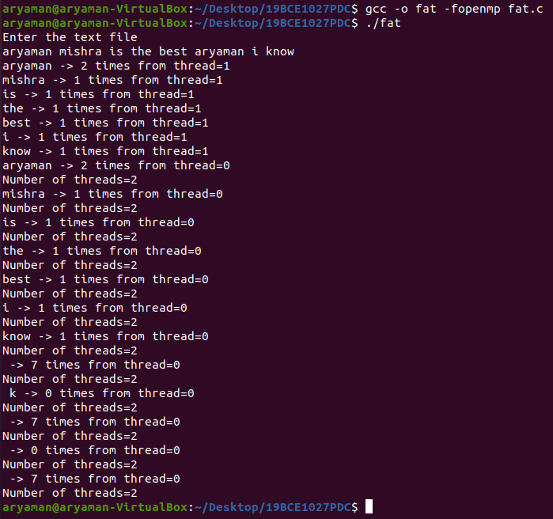

**Output Verified.**